Our Video Service
October to March Winter Video only Weddings 20% Discount
Sweet ‘n’ Simple £450 Weekend £650
less 50% EARLY BIRD DISCOUNT
Ideal if you want a quality video without the “bells and whistles”...........
Straight forward shooting and editing at an affordable price, coverage starts with the Brides arrival, the marriage service, photo shoot, receiving line and entrance to the Wedding Breakfast. 3 Dolby Digital DVDS in a presentation case, customised with photos from your Special day!

THE MATINEE £699 Weekend £899
less 20% EARLY BIRD DISCOUNT
Single Videographer recording arrival of Guests, Bridesmaids and Bride.
The wedding service, Video recording of the photographs, formal and
informal, the receiving line, cutting the cake and the speeches.
Service finishes after the wedding breakfast.
Extras on your 3DVD's to include:
Highlights of the day.
A mini movie of the entire day with music of your choice.

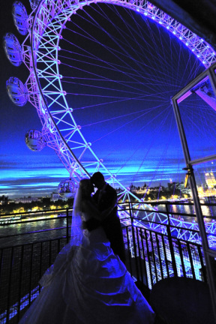

THE CLASSIC £799 Weekend £999
less 20% EARLY BIRD DISCOUNT
Single Videographer recording arrival of Guests, Bridesmaids and Bride.
The wedding service, video recording of the photographs, formal & informal.
The receiving line, speeches, cutting the cake and your first dance.
Highlights can be posted on You Tube
Extras on your 3 Dolby Digital DVD’s to include:
Fun Video Message from your guests, Highlights of the day.
A mini movie of the entire day cut to music of your choice.
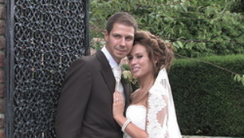

THE PREMIER £1299 less 20% EARLY BIRD DISCOUNT Weekend £1499
Two Videographers, 2 HD video cameras & our camera crane* , it really will give your wedding the WOW factor.
Our Premier presentation can cover:
First Videographer at the Brides home to record preparation and departure, second Videographer at the Wedding Venue to record the arrival of the Groom,
your Guests, Bridesmaids & the Bride.
All Cameras recording the wedding service from different angles.
The Photo Shoot, group photographs with candid shots of your guests, the Receiving line, Breakfast Entrance and the Speeches,
one camera recording the speaker, the other recording the reaction of your guests.
Cutting of the Cake.
Your First Dance and a taste of the evening atmosphere.
Highlights can be posted on You Tube.
Extras on your Dolby Digital DVD’s to include:
Fun Video messages from your Guests: Just what will they say or do?
Highlights of Your Special Day: A mini movie of the entire day with your choice of black and white visuals, contrasting colour and dreamy slow motion cut to music of your choice.
5 copies of your dvd in cases customised with photos of the Bride and Groom

THE ULTIMATE £1799 less 20% EARLY BIRD DISCOUNT Weekend £2000
Three Videographers, 3 HD video cameras & our camera crane , it really will give your wedding the WOW factor.
Our Ultimate presentation can cover:
First Videographer at the Brides home to record preparation and departure,
Second Videographer at the Wedding Venue to record the arrival of the Groom, your Guests, Bridesmaids & the Bride.
Third Videographer sets up camera crane at Venue to enable us to be able to get those fantastic floating shots seen in major films and television shows, it really will give your wedding the WOW factor.
All Cameras recording the wedding service from different angles.
The Photo Shoot, with candid shots of your guests, the Receiving line, Breakfast Entrance and the Speeches, one camera recording the speaker, the other recording the reaction of your guests, the camera crane recording interesting shots to be edited in to the movie.
Cutting of the Cake.
Your First Dance and a taste of the evening atmosphere.
Highlights can be posted on You Tube.
Extras on your Dolby Digital DVD’s to include:
Fun Video messages from your Guests: Just what will they say or do?
Highlights of Your Special Day: A mini movie of the entire day with your choice of black and white visuals, contrasting colour and dreamy slow motion cut to music of your choice.
5 copies of your dvd in cases customised with photos of the Bride and Groom
Add a little EXTRA
Visit to Bride’s home to record Wedding preparation and Bride’s departure – £60 (Free with Premier & Ultimate)
Childhood or honeymoon photographs of Bride and Groom, with music – £45 each or £60 for both.
Extended evening filming of the celebration atmosphere and the evening guests – £100 per hour.
* Camera Crane It really will give your wedding the WOW factor. £400
Marryoke Done properly this involves a lot of work and an extra cameraman - £400
(If you just wish to sing and we film as it happens there will be no extra charge)
Extra DVD’s – £9.99 each. Upgrade to a High Definition Blu-Ray disc: £50 first disc, then £20 per disc.
Quality DVD Cases Why not replace you standard dvd case with one of these quality cases Click here to view and buy
HD mobile version of your Wedding movie to watch on your Smart Phone, Ipad or USB £50.
Card payments are handled at PayPal, a secure online financial service. You can pay with a credit card without signing up for a Paypal account and there is no charge for the service. Please see our FAQs for help. Click here to pay your deposit
October to March Winter Video Weddings 20% Discount excludes bank holidays
Christmas Eve, New Year's Eve & New Years Day Special Fee applies, please contact us

